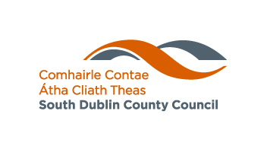

Placement Initiative - Office of the Mayor
Application Form

Name: _____________________________________________
Address: _____________________________________________ _____________________________________________
School: _____________________________________________
Phone: _____________________________________________
Email: _____________________________________________

Personal statement. (150 words max)

Detail any communication skills, involvement in the community and an interest in current affairs

______________________________________________________________
________________________________________________________________________________________________________________________________________________________________________________________________________________________________________________________________________________________________________________________________________________________________________________________________________________________________________________________________________________________________________________

NOTE:
Closing date for receipt of applications is Wednesday, April 8th at 5pm.

Application form should be emailed to communications@sdublincoco.ie
with subject titled ‘Shadow the Mayor’.

Applicants are required to be in transition year and residing or attending school in South Dublin County.

